Kansas State University
Remote Weather Station
ECE 590

Coalition of Weather Bois (COW-Bois)
10-29-2025
Members:
Gantzen Miller
Pete Ozegovic
Christian Evans
Kennedy Jones
Ben Rogers
Abdullah Ali

Executive Summary
Kansas State University oversees a Mesonet System where they collect data and review it over long periods of time. This data is helpful in many models, especially modeling climate change across Kansas over very long periods of time. The station should measure temperature, humidity, solar radiation, wind speed, wind direction, air quality, and precipitation at the minimum. The data also needs to be transmitted across Kansas wirelessly from a remote area. The station will also be able to communicate with smaller stations (micro stations) around the main station that will use the cell modem.
After brainstorming and research, there is not really any station that does exactly what we want it to do without being super expensive or custom. The only way we can implement the micro station systems is to hijack a commercial system, which is hard to check the feasibility of that option. So, our decision is to make a design that imitates a commercial station while also doing the same measurements as the Mesonet and can have maintenance easily done.
This design will cost about $600-$800 to make and test. The budget is separated into many categories that range from electronics and sensors to data plans and mechanical designs. Sensors will be tested before implementation using the testing labs of the Mesonet that can do temperature and solar radiation in a controlled environment. Close to the end of development, the plan would be to test the product in the field next to the Mesonet Station here in Manhattan so we can compare and correlate our data with the Mesonet data and see how close they match. This will help check the completeness of our project.
Table of Contents
Executive Summary 1
Project Description 4
Background and Motivation 4
Problem Statement 6
Project Requirements 7
Validation and Acceptance Tests 8
Verification and Validation Matrix 10
Data Needed to Support Analysis 11
Technical Design 12
Possible Solutions and Design Alternatives 12
Selection Process for Preliminary Design Solution 13
Data Pre-Processing and Exploratory Data Analysis 24
Preliminary Design/Solution Description 25
Global Issues 25
System-level Overview 26
Applicable Standards 30
Module-level Descriptions 32
Work Plan 35
Work Breakdown Structure & RACI Chart 35
Schedule (Gantt Chart) 37
Prototyping and Testing Protocol 38
Financial Plan 39
Proposed Budget 39
Feasibility Assessment 42
Lessons Learned 48
Conclusion 48
References 49
Appendices 50

Project Description

Background and Motivation
Weather has a very large effect on daily life, agriculture, infrastructure planning, and public safety. Having accurate and localized weather data is very important for understanding environmental conditions like temperature, humidity, precipitation, wind, and soil moisture, all of which have an influence on the decisions made by farmers, researchers, and emergency response teams. The Kansas State University (KSU) Mesonet gives these needed measurements through a network of automated weather stations across the state. Each station collects data on air temperature, humidity, wind speed and direction, precipitation, pressure, solar radiation, and soil conditions. The data is transmitted to centralized servers where they are quality checked and made publicly available to support research, agriculture, and environment management [2].
However, the current KSU Mesonet stations are expensive to build and maintain, costing around $19,000 per unit. This cost limits the number of stations that can be used and leaves certain regions of Kansas without coverage. The motivation for this project comes from the need to design a more affordable and mobile weather station that can give reliable, high-quality data at a much cheaper cost. By lowering expenses, the Mesonet could expand its network, improve localized data collection, and improve Kansas’s ability to track environmental conditions in real time.
Our team’s goal is to design a low-cost remote weather station, estimated at $600-$800, that measures key factors such as temperature, humidity, pressure, wind speed and direction, solar radiation, precipitation, soil temperature, soil moisture, and air quality. The system will be powered using solar power and battery storage, making it good for remote use. Each sensor will be “plug and play”, allowing for simple replacements, and the system will transmit data wirelessly to a centralized database.
The design follows national standards said in the American Association of State Climatologists (AASC) Recommendations and Best Practices for Mesonets, which says that Mesonets must have high quality data, consistent sampling rates, and reliable sensor accuracy to meet both scientific and public needs. [5]. For example, the AASC recommends that Mesonet air temperature sensors maintain an accuracy of ±0.5 °C, relative humidity sensors ±3%, and wind speed sensors ±0.3 m/s below 20 m/s [5]. It also says that reliable Mesonet networks should maintain 95% or higher data availability to ensure data completeness for climate and forecasting applications [5]. Our team aims to meet these standards while keeping the total system cost below $1,000.
Additionally, the AASC stresses that sensor exposure is very important for accurate data collection. Stations should be installed on flat, natural surfaces at least 100 m^2 in area and free from environmental bias like buildings or trees [5]. By making a smaller, more mobile, and cheaper design that can be used in a wide range of terrains, our weather station can help achieve better coverage in neglected regions, improving data coverage and consistency across the Kansas landscape.
By following these best practices, our project supports the KSU Mesonet’s mission to expand weather monitoring across Kansas through innovation and accessibility. This design's ultimate motivation is to close the gap between cost and quality, giving a maintainable and standards-following weather station that gives reliable environment data. Overall, the purpose of our design is to improve Kansas’s agricultural efficiency and weather awareness through innovative and affordable solutions.

Problem Statement
Overall, our design will implement sensors that accurately measure the desired parameters for a Mesonet Station and make the station affordable and easily maintained. The station will also include a parameter that can change the mode between a main station or a micro station for modeling microclimates around the station.

Project Requirements
Our project requirements are listed in the table below
ID | Project Requirements | Description
1.0 | Cost Efficiency (<19,00) | The current Mesonet station costs ~19,000. Our budget is $600 to %800
2.0 | Wireless Transmission of Data Distance being >= 410 Miles | Data will need to be transferred over the entire state of Kansas
3.0 | Easily replaceable sensors  (Convenient maintenance) | We want to be able to make the replacement of sensors as simple as possible, a plug and unplug approach makes this straightforward
4.0 | Off Grid Power Capabilities in a remote area | Needs to be a self-sustaining system and be able to power and charge itself
5.0 | Size maximum (1.5ft x 1.5ft x 1.5ft) | Overall maximum size that was mentioned to be maximum (cooler sized)
5.1 | Size minimization | Though we have a maximum, we should shoot for a smaller compact system
6.0 | Sensor Accuracy | Our sensor accuracy varies between the types of sensors
6.1 | Temperature | Our Temperature sensor needs to meet the Mesonet standard of ~0.3°C - ~0.4°C
6.2 | Humidity | Our Humidity sensor needs to meet the Mesonet standard of ~2% - ~3%
6.3 | Solar Radiation | Our Solar Radiation sensor needs to meet the Mesonet standard of ~5% (Resolution 0.2 W/m^2
6.4 | Wind Speed  Wind Direction | Our Wind Speed sensor needs to meet the Mesonet standard of ~0.3 m/s, Wind Direction needs to be ~3°
6.5 | Precipitation | Our Precipitation sensor needs to meet the Mesonet standard of ~1% - ~5% (Resolution 0.254mm)
6.6 | Air Quality | Mesonet does not currently have an Air Quality standard
6.7 | Pressure | Our Pressure sensor needs to meet the Mesonet standard of (~1mb)

Our first requirement is cost efficiency; the current mesonet setup costs roughly $19,000. This makes it very expensive to have multiple stations in a smaller radius. Our goal is to reduce the cost so the mesonet can have more stations, giving a clearer picture of the climate across Kansas. Our aim is to keep our cost within the $600 to $800 range. Our next requirement is wireless transmission capability. Our weather station is intended to be in remote locations, so wireless communication is essential. Data will need to be transmitted across the entire state of Kansas, roughly 410 miles. Sensors also need to be easily replaceable due to the remote location. If the sensors are simple to replace, like a plug and unplug approach, it would not require a skilled technician to replace. This would reduce costs, as well as make it easily maintainable. The station also needs to be self-sufficient, we don’t know exactly where these stations will be located, so we need to ensure they will be able to be powered anywhere. Our stations need to be able to power and charge themselves. The size of our station also needs to be considered. We want our station to be able to be transported easily, without any special equipment. Our size requirement is a maximum of 1.5ft x 1.5ft x 1.5ft, although a smaller, more compact design is our goal.
For our sensor accuracy, the Mesonet already has requirements for their current sensors on its website [1]. We are aiming to meet these requirements, but we realize that it may not be possible due to the scope of our project. Regardless, we are aiming to be as accurate as possible.

Validation and Acceptance Tests
The verification matrix shown in the Verification and Validation Matrix section outlines the approach we will use to verify each of the requirements we need to meet for our project. The cost effectiveness of our design will be evaluated in an analysis once it has been fully constructed. It will be straightforward to do so, as we will only need to measure the final cost of our system’s components against our original budget.
Verifying the wireless transmission distance of our design is less straightforward than verifying cost efficiency. Instead of testing whether the design can transmit the full 410-mile radius, we will instead demonstrate that it can transmit over a shorter distance. This creates less of a burden on team members, as driving 410 miles would be an all-day endeavor, something engineering students certainly do not have time for.
To verify convenient maintenance of the weather station, we will demonstrate its modularity by looking at how easy it is to replace or remove faulty parts. The goal with our station is to, of course, create a design that can be easily maintainable by a layman who may not have the electrical engineering expertise that we have. Therefore, it is crucial that we create something that is “plug-and-play.” Verifying this will be as simple as trying to replace a sensor quickly. We may even have a non-electrical engineer look at our design/instructions and see if they can easily figure things out.
The verification of both the design being sustained by off-grid power and the footprint of our station will be a simple check at the end of design. Does our design source power from anything on the grid? Does our design fit within a 3.375 cubic foot box?
In terms of size minimization, however, the verification process is slightly more convoluted. We don’t have a goal to shoot for smaller than the 3.375 cubic foot requirement. But minimizing our design further improves portability and subtly, allowing the station to be less obtrusive and obvious in the environment (as opposed to a massive tower on the horizon).
Last, the sensors. The reason the sensors will be verified through testing is because we must ensure that they work accurately when implemented into the whole system. Early on in our design, we will ensure the accuracy of the individual sensors that we will be moving forward with, but we must ensure that they maintain that accuracy when integrated into the greater system. This must be done by testing the system. Specifically, we will be setting up our completed system and collecting data near one of the Mesonet’s existing towers so that we can compare the quality of our data to the quality of the data their existing equipment is collecting.

Verification and Validation Matrix
ID | Requirement | Verification Method
 |  | Analysis | Demonstration | Inspection | Test
1.0 | Cost Efficient | X
2.0 | Wireless Transmission Distance |  | X
3.0 | Convenient maintenance |  | X
4.0 | Off Grid Power |  |  | X
5.0 | Size maximum |  |  | X
5.1 | Size minimization |  | X
6.0 - 6.7 | Sensor Accuracy |  |  |  | X

Data Needed to Support Analysis
To confirm our design meets the required sensor accuracy, we need to have data from the Mesonet’s current design measured at the same time our design is being tested. This will require a short term (1-3 day) test of our weather module near one of the existing towers. The Mesonet’s measurements will act as a baseline for the confirmation of our sensor’s required accuracy.

Technical Design

Possible Solutions and Design Alternatives
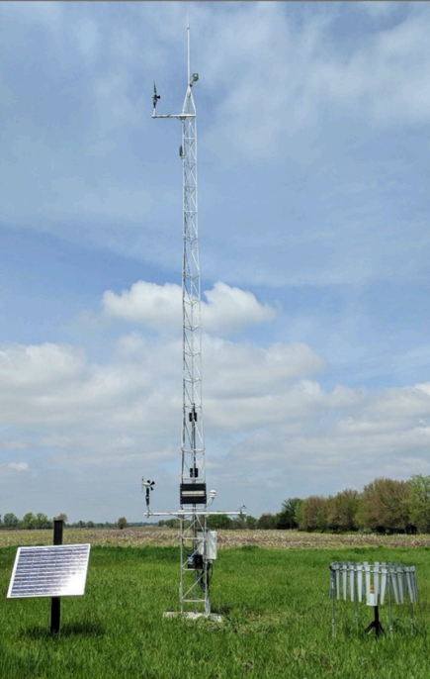
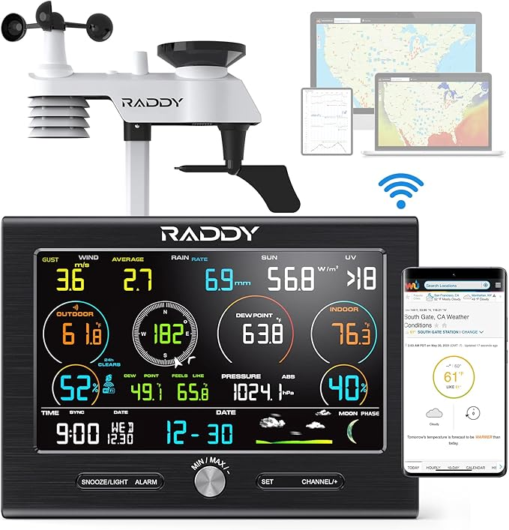
Design parameters and requirements point towards the idea of a commercial weather station. It is small and can perform most of the Mesonent Station Measurements and meets the budget and timeline of the available class time we have. In Figure 1, it shows the current Mesonet Station. The tower and all the sensors together cost more than $19,000 to produce and as of October 2019 they have installed 62 stations across Kansas [2]. Some of the stations are not 30-foot towers either, some are just tripod stations. So, to avoid this hefty cost and maintenance of a 30-foot tower, the plan should be a smaller commercial looking station and test the accuracy compared to the Mesonet Station to see how closely it aligns.
Figure 1: KSU Mesonet Current Tower (Ref)
Figure 2: Wireless Remote Weather Station from Amazon by Raddy
Researching design alternatives, we find the usual option like the one pictured in Figure 3. These are good options because they are not super expensive and measure some of the required data values up to close accuracy that compare to the Mesonet Stations. They seem like good options except for one of the requirements of easy maintenance (this is due to the whole station being replaced rather than just the broken sensors). The other is micro station modeling. From our research we could not really find a station that could send data to another station and transmit long distances. None of the stations really provide this opportunity. Stations that just transmit to one data server do exist, but they are not cost effective and do not do all the required measurements.
Another idea that came to mind was hijacking a design that was already made. We could hijack the current station tower with our own box that does all the controls. This could be a potential solution but does not provide an innovative solution. The other issue with this approach is feasibility. Is it possible to implement some of the sensors they use into our planned design? This also does not solve the budgeting problem.
In terms of hijacking, we could also hijack a commercial weather station, but it will be hard to find an exact station that does what we want. So, the feasibility of this approach is a bit riskier and might not even do exactly what we want it to do.

Selection Process for Preliminary Design Solution
The decision regarding the design that we settled on was to make our own commercial station. Other stations do what we want to a certain level but there is no exact station that does exactly what we would want for our implementation. Hijacking the system seems to be a good second alternative but we would still need to check feasibility of the mechanical attachments for the station tower they already have, plus make some sort of setup for the micro station and add additional sensors that are missing. The best option of the design to meet all the requirements would be a small commercial station that can be easily installed and has quick maintenance. So now we must find individual parts for each requirement that our system needs. The parameters are as follows:
- Sensors
  - Adafruit Chips for measuring
  - Addition Sensors built for budget
- Microcontroller
- Cell Modem/long range communication device
- Some form of power supply or battery system
These decisions will be made in greater depth starting with sensors:
When choosing sensors, there were a few considerations, price, durability, accuracy, connectivity, and if it was a single sensor or a combined sensor package. Due to budget constraints, the current mesonet sensors are out of our budget. A priority of ours is to use modular sensors, while many companies’ offer these, Adafruit offers quality sensors within our budget that use modular technology. Their “STEMMA QT” connectors allow users to plug into their sensors instead of soldering [3]. This is very desirable as it would allow for sensors to be easily replaceable. Accuracy of our sensors is also very important, many sensors are within our desired range, but further testing will be required to confirm their specifications. As for durability, there are a few solutions to explore. Most modular sensors are essentially just protoboards with no housing. This means the durability of our sensors will be reliant on the design of our weather station. Some solutions include 3D printed housing, covering in resin, and wrapping in plastic. Further testing will be conducted to find the most efficient solution. Also considered was whether it was a combined sensor package. If a sensor is measuring more than one parameter accurately, that would be desirable. That would cut costs because an additional sensor would not need to be purchased, as well as allow for a more compact design. However, if the sensor accuracy was compromised due to the combination, the single sensor would be chosen. This is another parameter that will ultimately be decided through further testing.
 | Temperature |  |  | Radiation |  | Soil |  | Air Quality
1 – 5)  1 is worst, 5 is best | Adafruit Temp and Humidity | Adafruit Temp, Humidity, and Pressure | Adafruit Temp | Solar Radiation | Ambient light | Soil Temp and Moisture | Adafruit Soil Temp | Adafruit Air Quality | Adafruit Air Quality Stemma
Price | 3 | 2 | 4 | 1 | 4 | 3 | 5 | 2 | 4
Durability | 3 | 3 | 3 | 3 | 3 | 5 | 2 | 3 | 3
Accuracy | 3 | 1 | 4 | 5 | 5 | 5 | 2 | 3 | 2
Connectivity | 5 | 5 | 5 | 2 | 2 | 5 | 5 | 5 | 5
Combination | 3 | 5 | 2 | 1 | 1 | 5 | 5 | 1 | 1
Total Score | 17 | 16 | 18 | 12 | 15 | 23 | 19 | 14 | 15

For the sensors that we are going to build, we decided that the ones that seemed to be the most feasible to construct and save us some money are the wind speed/direction sensor and the precipitation sensor. For these designs we made the decision matrix below in table.
Criteria​ | Description​ | Importance (1-5 scale)​ | Bend senor Anemometer | Sonar Anemometer​ | Ping Pong Ball Anemometer and fin​ | Seesaw with weight sensors​ | Scale water dump method​
Feasibility​ | Is it even possible?​ | 5​ | 4 | 2​ | 5​ | 3​ | 4​
Budget​ | Does the design fit our budget?​ | 5​ | 5 | 2​ | 3​ | 4​ | 4​
Durability​ | Will it break easier due to elements?​ | 3​ | 5​ | 5​ | 3​ | 4​ | 3​
Accuracy​ | Will it accurately read what we need?​ | 4​ | 4​ | 5​ | 3​ | 4​ | 4​
Total​ | ​ | ​ | 76 | 55​ | 61​ | 63​ | 65​

These designs seemed to be the ideas that popped up the most for the wind speed/direction and precipitation.
For wind speed/direction, we decided to go with the flex sensor method because it provides less mechanical moving parts and seemed feasible with our timeline. This helped us decide because it will be cost effective and less moving parts could potentially increase the lifespan of the anemometer. This design was made and tested by “Smart Solutions for Home” on YouTube and proves to work quite well [4]. Following a similar design approach makes this more feasible.
For precipitation, we are conflicted with the designs because they all scored very closely to one another. In the end we decided to try the rain gauge that measures the weight of the water. According to the American Association of State Climatologists’ (AACS) adopted article titled "Recommendations and Best Practices for Mesonets”, they mention that weighing rain gauges using load cells is commonly used in high accuracy systems. They also mention wind shields surrounding the precipitation sensor to help guide the water into the sensor more, but it recommends it but does not require it [5]. It gives us something to think about when it comes to designing the final product.
Criteria​ | Description​ | Importance (1-5 scale)​ | ESP32-WROOM-32U | STM32F407 | RP2040
Feasibility​ | Can it handle sensors & wireless? | 5​ | 5 | 4​ | 3
Budget | Fits within project cost?​ | 4​ | 5 | 3​ | 4
Capabilities​ | Processing power, memory, I/O | 5​ | 5​ | 4 | 3
Integration​ | Ease of adding sensors & communication | 5 | 5​ | 4​ | 3
Reliability | Suitable for outdoor/long-term use | 3 | 4 | 4 | 3
Community Support | Libraries & documentation | 2 | 5 | 4 | 3
Total​ | ​ | ​ | 131 | 101 | 84​

When choosing the best microcontroller for our remote weather station, we looked at three different options: the ESP32-WROOM-32U, STM32F407, and RP2040. Each microcontroller was scored based on six factors, including feasibility, budget, capabilities, integration, reliability, and community support. These factors were given weight based on how important they are to meeting our project goals, as shown in the decision matrix above.
The ESP32-WROOM-32U scored the highest overall score with 131 points. Coming in second was the STM32F407 with 101 points and the RP2040 was last with 84 points. The ESP32-WROOM-32U scored the best because it is powerful, affordable, and has built-in Wi-Fi and Bluetooth. This allows it to handle multiple sensors and wireless communication without extra hardware. This makes our design simpler, cheaper, and easier to maintain.
The STM32F407 has good processing power and reliability, but it is more expensive and needs extra components for networking. The RP2040 is cheap, but it lacks wireless capability and has less processing power, making it not a great choice for our design.
Another important reason for choosing the ESP32-WROOM-32U is its large community with many well-supported libraries and documentation. This will make development and troubleshooting much faster and easier once the build phase begins. Overall, the ESP32-WROOM-32U gives the best balance of cost, performance, and ease of use, making it the best choice for our remote weather station design.

Criteria​ | Description​ | Importance (1-5 scale)​ | Notecard Cellular LTE Cat-1​ | Quectel BG95​ | LILYGO T-SIM7600G-H R2​
Feasibility​ | Compatibility with planned sensor setup​ | 5​ | 4​ | 4​ | 5​
Integration​ | Ability for integration with ESP32 and I2C​ | 4​ | 4​ | 3​ | 5​
Capabilities​ | 4G LTE capability​ | 5​ | 5​ | 5​ | 5​
Power Consumption​ | Does the modem draw an unreasonable amount of power?​ | 4​ | 4​ | 4​ | 4​
Budget​ | <$200 Price​ | 5​ | 4​ | 5​ | 4​
Total​ | ​ | ​ | 97​ | 98​ | 106​
The modem selection followed a similar pattern. Several options were considered then narrowed down to a top three, which were compared against each other across the categories of feasibility, integration, capabilities, power consumption, and budget. They were then given a weighted score, and the highest score would be selected. These results are summarized in the following table:

As can be seen, the LILYGO T-SIM7600G-H R2 scored the highest of the three. While each of the other two options, the Notecard CAT-1 and Quectel BG95 would likely work, the LILYGO fits our needs the best because it comes pre-integrated with the EPS32. The LILYGO is built onto the same board as the ESP32, which naturally allows it to be streamlined seamlessly. It is compatible with I2C and has 4G LTE capability, along with a very reasonable price of $58.50. This modem will be able to transmit data over long distances and satisfy all of the criteria of our design.

Criteria | Description | Importance (1-5 scale) | Solar Panel and Battery | Wind Turbine Generator | 3 Phase AC Integrated with Solar
Feasibility | Is it even possible? | 5 | 5 | 0 | 0
Budget | Does the design fit our budget? | 5 | 4 | 0 | 0
Efficiency | Is the design able to provide the needed power efficiently? | 4 | 3 | 5 | 5
Consistency | Is the design able to supply the needed power consistently? | 5 | 3 | 3 | 5
Total |  |  | 72 | 35 | 45

The power system required for our remote weather station is quite robust, as will be detailed in the paragraphs below. We first needed to decide on a feasible design route given the time and resources we are given, namely budget. The table above details our decision matrix for three separate top level design ideas our power team initially had.
Our device will be operating completely off the grid in remote areas of Kansas; therefore, the power system needs to be robust enough to avoid frequent maintenance trips. The K-State Mesonet maintains weather stations in most Kansas’s counties, including stations in all 7 of the state’s counties bordering Colorado. The logistics behind taking weekly trips to these counties five plus hours away is ridiculous to consider given the manpower of the Mesonet team.
With that in mind, our initial idea was a solar panel and battery setup. The benefits of this design are evident given the main requirement detailed above. It is also very budget friendly, the main cost obviously being the battery and solar panel themselves as conversion equipment is cheap to buy or build. This design falls short in efficiency and consistency. The current technology within solar panels is not nearly as efficient as its renewable counterpart wind generation. There is also the obvious dependance on the weather conditions of the environment the station is placed in. If the sun doesn’t shine, power is not generated.
Related would be the use of a wind generation system, or a wind turbine. Immediately this design choice falls short in the budget category. While not as expensive as our next design option, a wind turbine fitting our rough size estimate would cost $100-150, a quarter of our design budget for one component! Wind generation is more efficient in some ways, and Kansas is certainly a good place to harness the wind. It too, however, is dependent on weather conditions for its reliability.
Last would be the incorporation of 3-phase into our distribution system. Right off the bat we must ask ourselves this question: “What’s the point?” 3-phase is hyper-efficient yes, but the main reason it is used in large scale distribution systems is to reduce transmission line losses. What truly are the odds we are going to run into issues with transmission line losses? And is added complexity worth the added cost of an investor when we can solve the issue with more simplified means learned in electromagnetic theory?
Therefore, we went for the simple battery and solar panel design as the most feasible in our time frame and budget range as well as minimizing the risk of an incomplete project come May. What then will this design look like? What are we dependent on from the other areas of our design before we can begin sizing and designing our power system layout?
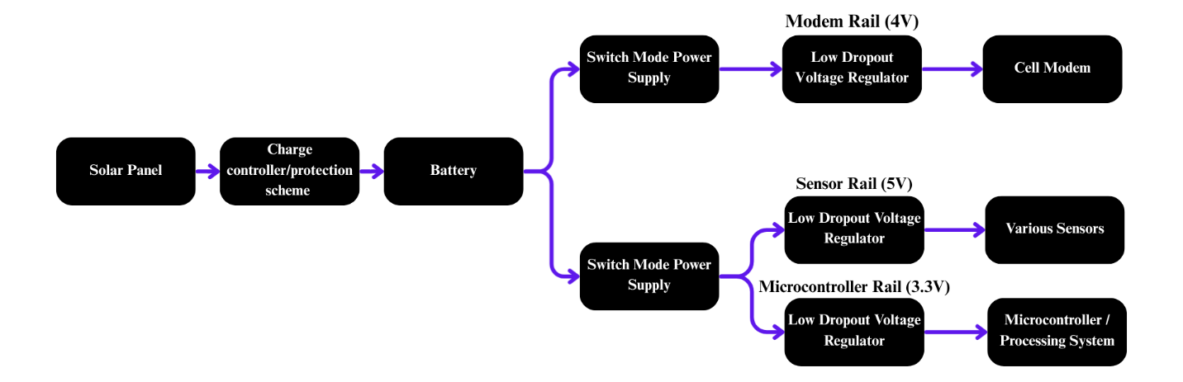The figure above details a very rough outline of what our design will look like. While it may seem counterintuitive to the way the chart is set up, we will begin our design on the right and work left. Before anything can be sized, any converter can be designed, we must know the amount of current each of the three main design sections of our system will need. The sensors will be straightforward. Kennedy, upon testing of the sensors, will be able to give us an accurate estimate of their current draw. The sensors will always draw this level of current. The microcontroller should be similar, unless the interaction between it and the modem affects its drawing during transmission. Currently, it looks like the ESP32 will draw at most 100 mA if the modem does not affect it. And then of course, the complex piece is the modem. We will have to set some sort of duty cycle and control for the modem. When it transmits, it can draw very briefly up to around 2 Amps of current, a hefty sum.
Figure 3: Top Level Design Flow of Power System Design
These things are obviously quite variable, and we are unable to pin them down now, so the beginning of the power system design process is still far off. Once we know the amount of current each component of our system draws, we will be able to size the battery and solar panel, and then from there design the conversion process to cater to the system’s specific needs. The basic outline is clear though. We will need a charge controller/MPPT to control and monitor the power generation of the solar panel. We will need at the very least two switch mode power supplies to generate a constant and a variable current level (one will require a duty cycle as mentioned above to supply the modem). And we will need more precise low dropout voltage regulators to tune the voltage for each component (we need three separate voltage levels!).

Data Pre-Processing and Exploratory Data Analysis
Once again, our design is not dependent on analyzing data beforehand to make our design. The data and measurements we must take are during the design (testing sensor accuracy) and after the design is finalized (to compare with the Mesonet data). The data we will need from the Mesonet is on their website and open to use. This data helps us correlate whether our data is up to the Mesonet standard while also being cost effective. Our extracted data will be used during testing at the beginning and then finalized and collected by a home assistant server. The data we are extracting from our system during testing will just be saved locally on the microcontroller and computer. The data taken from our final design will be transmitted through an MQTT Broker and stored on a server that can be extracted as CSV files.

Preliminary Design/Solution Description

Global Issues
- Climate Change and Weather Monitoring
- Summary: Climate change is causing harsher weather events like droughts, floods, and heatwaves. This is a worldwide problem, and Kansas is affected by it too. Farmers and researchers need local weather data to help prepare for these events to reduce damage.
- Resolution: Our weather station design helps by being low cost and mobile. This will allow it to be placed in more rural areas that don’t have coverage currently. This will improve weather tracking in Kansas and could help with global climate tracking as well.
- Energy Efficiency and Sustainability
- Summary: Energy use and sustainability are very big concerns when making a design like this. Remote weather stations need to run continuously, even in areas without reliable power.
- Resolution: Our system uses solar panels and rechargeable batteries to stay powered without relying on outside electricity. Our microcontroller, the ESP32, also can run in low power mode, which helps it last longer and keeps the station environmentally friendly.
- Data Accuracy and Reliability
- Summary: Accurate data is important for scientists, farmers, and safety teams. If data is missing or unreliable, it can lead to wrong decisions.
- Resolution: We follow the AASC standards for sensor accuracy and data quality. Sensors will be calibrated and tested before use and designed for easy maintenance [5].
- Affordability and Accessibility
- Summary: Even though the design is for the KSU Mesonet, many areas around the world still cannot afford expensive weather stations and could use this design. Not being able to afford expensive weather stations limits their ability to collect reliable weather data.
- Resolution: Our project focuses on making a station under $800, using affordable parts like the ESP32 microcontroller. The station would be easy to repair and cost effective. This would mean more stations can be used, even in developing areas with less money.

System-level Overview
After all the decision matrices were made, we decided to make a small station that will include all desired measurements and will be able to be implemented easily. The block diagram for the design is shown in Figure 4:
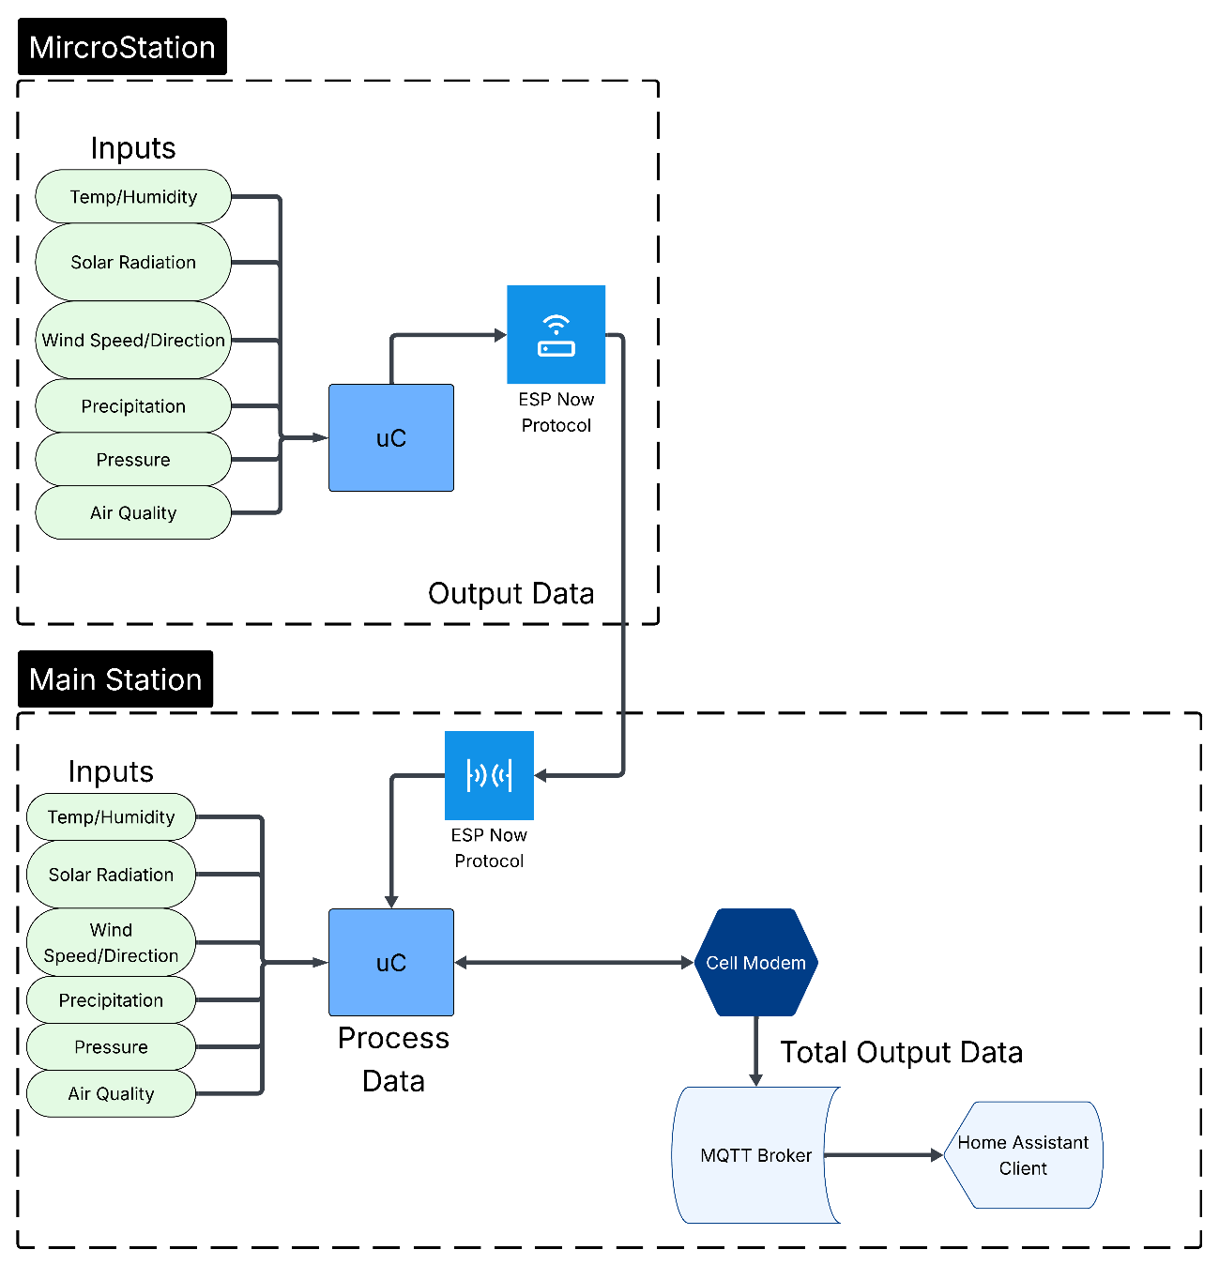
Figure 4: Block Diagram of the Design
This diagram showcases the use of a main station with a sim card and then the micro station that uses ESP Now protocol to communicate with one another (why it is important we have the ESP32 microcontroller). This design also showcases the transfer of data from the inputs, being processed by the microcontroller and finally being sent out using a Message Queuing Telemetry Transport (MQTT) protocol to transmit the measured data over a long distance to a receiving client server like home assistant. The inputs will communicate with the microcontroller with I2C or some other form of digital protocol (different for the built sensors). The data will be processed and averaged then transmitted. If the station is a micro station, it will transmit the data via ESP Now protocol. If it is a main station, it will get transmitted using a cell modem and the receiving server client will receive the data which can then be extracted or processed. The design follows a commercial station with built sensors (that will probably follow previously made designs).
Next is a rough sketch of what the station might look like. Now this is a very rough sketch because it will depend on the size of the sensors and power system required for the station to operate. The idea is to put the wind gauge anemometer in the middle and have everything be below it. This is so the wind speed is not affected by any other sensor. The precipitation and power will be on the sides to have more accurate reading, and the anemometer also helps act as a wind shield for the precipitation. Now for power it might be a separate level closer to the ground but that will depend on how much power is needed which will decide the battery and solar panel required. The rough sketch of the station is below in Figure 5:
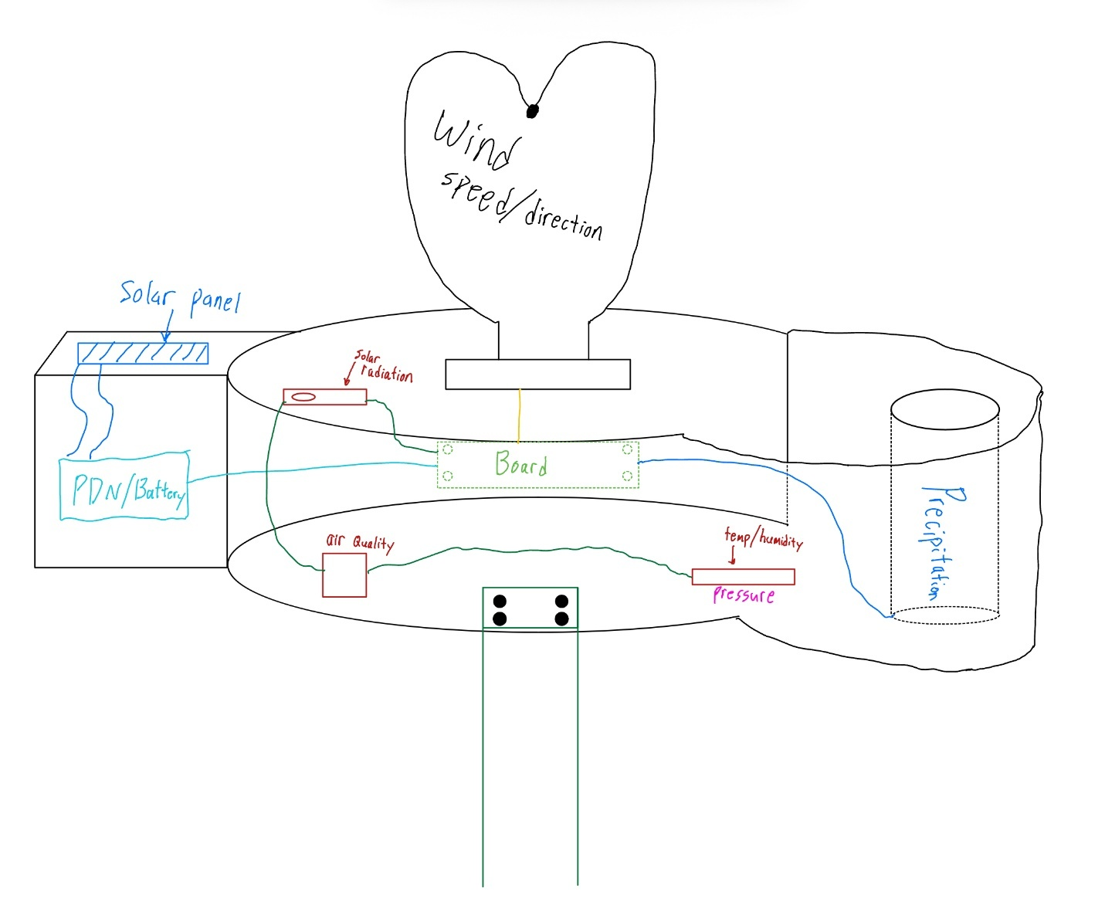
Figure 5: Rough Sketch of Weather Station

Our relevant reference is the station pictured in Figure 2. This station is set up on a rod and takes measurements and sends data to an online server.

Applicable Standards
Main System and Communication Standards
JEDEC Standard JESD8-3 – Standard for TTL (Transistor-Transistor Logic) voltages. The interface that we are using in our project is the 5V logic interface for most of our sensors and processing [6].
NXP UM10204: I2C-bus Specification and User Manual – Industry standard of a communication protocol over short distances between chips and devices using two communication lines. One clock line and one data line [7].
FCC Title 47 CFR Part 15 (Unlicensed Transmitters) – Because our device is a radio frequency device, we need to comply with the FCC Regulations and make sure we can transmit our data using a cell modem [8].
Adafruit Stemma QT Overview; JST SH Connector Datasheet – Not an industry standard but a connection standard set by Adafruit to connect multiple sensors together with I2C. If we make this our standard, then maintenance will be a lot easier [3].
3GPP (3rd Generation Partnership Project) System Architecture – International standards for 2G, 3G, 4G, 5G, and LTE communication​
- The modem we select must comply with this standard.

Power System Standards through IEEE [9]
IEEE Std 1547™-2018 – Standard for Interconnection and Interoperability of Distributed Energy Resources with Associated Electric Power Systems Interfaces
- Goes over the common practices and design requirements for voltage converters (switch mode power supplies).
IEEE Std 1547.1-2020 – Standard Conformance Test Procedures for Equipment Interconnecting Distributed Energy Resources with Electric Power Systems and Associated Interfaces
- Includes ways to confirm correct functionality of converter design and performance.
IEEE Std 1547.9-2022 – Using IEEE Std 1547 for Interconnection of Energy Storage Distributed Energy Resources with Electric Power Systems
- Outlines how to integrate batteries into small scale power distribution systems.
IEEE Std 2030.2.1-2019 – Design, Operation, and Maintenance of Battery Energy Storage Systems, both Stationary and Mobile, and Applications Integrated with Electric Power Systems
- Will help with battery selection for the needs of our system.
IEEE Std 1679 (family) – Recommended Practice for the Characterization and Evaluation of Energy Storage Technologies in Stationary Applications
- May not be as useful, deals mostly with battery chemistry, could affect selection based on the environment (Kansas).
IEEE Std 519-2014 – Recommended Practice and Requirements for Harmonic Control in Electric Power Systems
- Helps establish harmonic limits (in layman’s terms, helps eliminate issues that may arise when using switches and how that may interact with the sensors and other components). This will be useful in controlling our power system’s delivery (namely, the modem).

Module-level Descriptions
For the module level descriptions I can discuss the inputs, processing of the data, and receiving the outputs. For the inputs, it takes measurements using some form of I2C or data transmission. This process includes taking the data using an Analog-to-Digital Converter (ADC) and transmitting the data. Most of these sensors will be some Adafruit chip. This is useful because it can be purchased easily and has a Stemma QT connector system which could make for a standardized maintenance system (which makes it easier to maintain and fix) [3]. The only stranger ones will be the wind speed/direction sensor and the precipitation sensor. These are more difficult to account for because they will be a direct system. Another positive thing about our design is that we can grant access to additional input measurements. This allows the user or customer to add additional sensors later as inputs and make the system input and transmit more data (assuming they have the need and budget to transmit more data).
Next is the microcontroller. It needs to take measurements every 3 seconds (depending on how much power each measurement tool uses) and then transmit the data every 5 minutes. This is the recommended timeline for data collection and transmission according to the AASC document [5]. How the data gets transferred depends on whether the station is the main station with the modem and SIM card or if it is a micro station that just needs to get the data to the main station. How we would make this process selection is to have one code that can have a shorting header pin. If the pin is in/out, then the station can be a main/micro (however the program is made will decide this).
Lastly, the output of the data. This is dependent on the configuration of the controller. The plan is to try to make it a physical plug to decide whether it is a main station or micro station. After the configuration of the system, it will follow that block diagram in Figure 6. 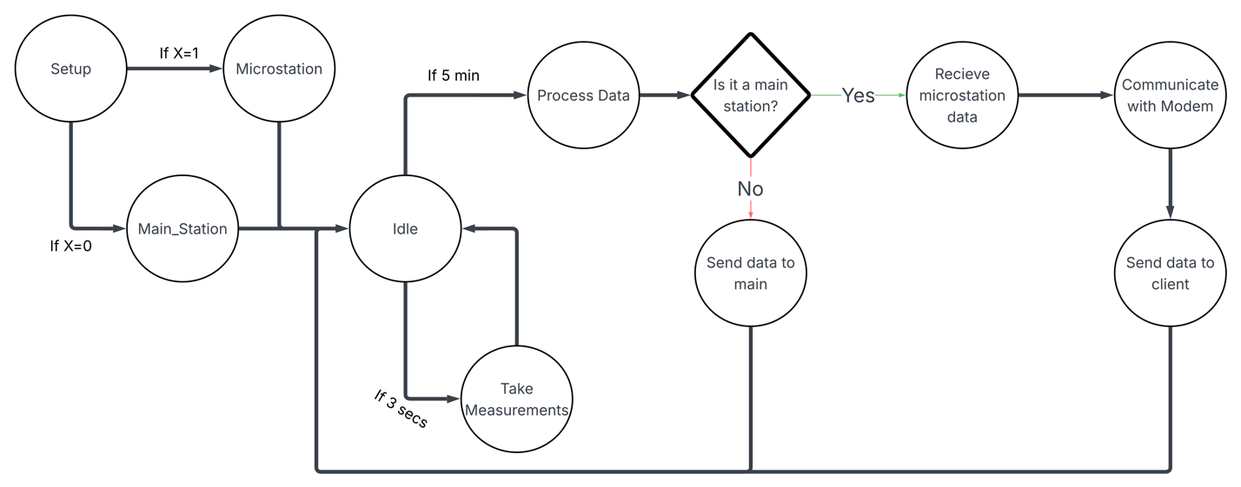
Figure 6: State Machine of Microcontroller
If it is a micro station, it will transmit the data to a main station. That is all the micro station must do. For testing purposes, we could just make a quick micro station that just does temperature and humidity to make sure this process works.
If it is a main station, then the process gets a bit longer. The main station first has to receive the data from the micro station(s). Once it receives all the data it will load it up and send it to the cell modem. The cell modem then transmits the data wirelessly over long distances to be received by a client that can extract the data and observe it. The data should be able to also be extracted as a csv file so we can store it long term. The overall bullet points of the system modules are as follows:

- Inputs:
  - Adafruit Sensors using I2C
  - Built Sensors using some ADC to send to the microcontroller
- Processing:
  - Taking measurements every 3 seconds (if reasonable)
  - Taking an average of over 5 minutes
  - Receiving micro station data using ESP Now
- Outputs:
  - Organizing data
  - Sending data to the cell modem using AT commands
  - Sending data to the MQTT Broker
  - Getting the data to a client server that can see and process the data
  - Data format in some form of csv

Work Plan

Work Breakdown Structure & RACI Chart
The work plan for the product cycle is separated into 4 phases, phase 1 (Designing and Testing), phase 2 (Construction and Build Testing), phase 3 (weather proofing and checkoffs), and finally phase 4 (Field Testing and Data Comparison). The Table below shows the RACI which stands for Responsible, Accountable, Consulted and Informed. These specify which members have which responsibilities. For members that are accountable, they help assist the member that is responsible for the task and also make sure they are on schedule for deadlines. Consulted members are members that need to know the progress of the task being completed. Lastly, I believe all members need to be informed on how things are going in each part of the project.
Each member has a general design style that they are assigned. It is as follows:
- Gantzen Miller - Hardware/Mechanical Design
- Kennedy Jones - Hardware/Mechanical Design
- Pete Ozegovic - Software Design
- Ben Rogers - Software/Hardware Design
- Christian Evans - Power System/Hardware Design
- Abdullah Ali - Power System Design

ID | Task | Gantzen Miller | Kennedy Jones | Christian Evans | Abdullah Ali | Pete Ozegovic | Ben Rogers
Phase 1 (Starting Designs)
#1.0 | Program Interface | I | C | I | I | R | A
#2.0 | Test Sensor Accuracy | A | R | I | I | C | I
#3.0 | Build Sensors | R | A | I | I | C | I
#4.0 | Modem Setup (MQTT) | C | I | I | I | A | R
#5.0 | Power Circuit Design | C | I | R | A | I | I
#6.0 | Power Component Selection | C | I | A | R | I | I
Phase 2 (Construction and Physical Testing)
#7.0 | Sensor Interfacing Plan | C | R | I | I | A | I
#8.0 | Test Built Sensors | A | C | I | I | R | I
#9.0 | Modem Communication Setup | C | I | I | I | A | R
#10.0 | PDN Construction | C | I | R | A | I | I
#11.0 | Solar Panel Construction | C | I | A | R | I | I
#12.0 | PCB Design of Controller | R | I | I | I | C | A
Phase 3 (Weather Proofing Finalization and Checkoff)
#13.0 | Box Design | R | C | I | I | I | A
#14.0 | Sensor Layout Design | A | R | I | I | I | C
#15.0 | Weather Proofing Design | C | A | I | I | I | R
#16.0 | ESP-Now and Code Finalization | I | I | A | C | R | I
#17.0 | Combine Solar Setup and PDN | I | I | R | C | I | A
#18.0 | PDN Trouble Shooting | I | I | A | R | I | C
Phase 4 (Field Testing and Project Comparison)
#19.0 | Data Science Code Construction | C | I | I | I | R | A
#20.0 | Tying PDN to Station | C | I | R | A | I | I
#21.0 | Field Testing | A | R | I | I | I | C
#21.1 | Field Install | R | A | I | I | I | C
#22.0 | Data Analysis | C | I | I | I | A | R
#23.0 | Troubleshooting and Problem Reporting | C | I | A | R | I | I

Schedule (Gantt Chart)
Below in Figure 7 is a picture of the Gantt Chart Schedule. It follows the same format as the RACI Chart and Phases mentioned in the last section. Specific members are responsible for specific parts of each phase and there is overlap in the phase sections and between phases. However, there still needs to be a project flow of the timeline. Something to note is the deadline dates. All the dates are based around the Spring Semester, but we can start before the Spring Semester and get ahead on the Gantt Chart.
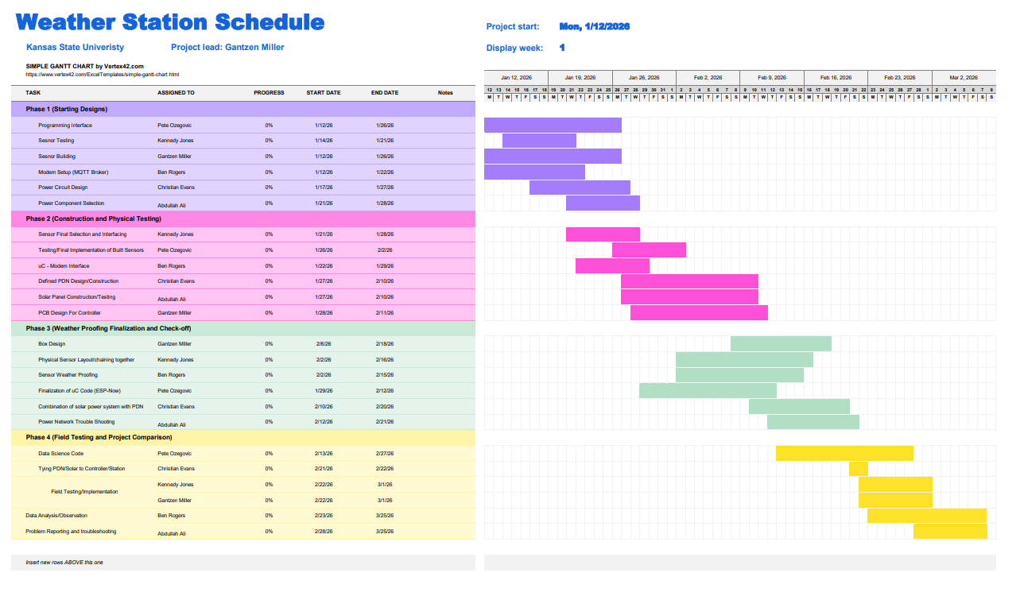
Figure 7: Gantt Chart Schedule

Prototyping and Testing Protocol
The majority of our prototype and testing will be done for our sensor selection. We plan to purchase a few types of each sensor and do our own testing to ensure accurate results. The K-State Mesonet has a laboratory that they have given us access to use. This laboratory has equipment that can control variables needed to test the accuracy of our sensors. The equipment can control temperature, humidity, pressure, precipitation, and many other variables. We will use this laboratory to test our sensors and select the one that is the most accurate.

Financial Plan

Proposed Budget
In this section, we present the proposed budget for our project. As a team, our goal is to keep the total cost within the range of $600–$800 while ensuring that we use reliable components and materials. Some costs, particularly for the power system, are still being evaluated, so we have provided estimated ranges instead of exact values. We have organized our budget into two sections: one for the Bill of Materials (COGS), which includes the main components used in our final design, and another for Test Equipment/Apparatus, which lists tools and resources we will use during testing and prototyping.
1. Bill of Materials (COGS)
Item | Purpose | Estimated Cost (USD) | Priority | Contingency Plan
Sensor Suite | Used to measure temperature, humidity, pressure, rainfall, wind, and solar radiation in our design. | $150–$200 | High | If not funded, we will use simulation data or university lab sensors for testing.
Microcontroller (ESP32 or equivalent) | Manages data collection and wireless communication in our system. | $20–$80 | High | If necessary, we can use a lower-cost controller or connect via wired link temporarily.
Power System (Solar panel, battery, charge controller) | Provides renewable energy for off-grid operation. | TBD (~$150–$200) | High | We will simulate solar and battery behavior in the lab until actual parts are available.
Enclosure and Structural Frame | Protects electronics and ensures our design is weatherproof and stable. | $80–$100 | Medium | We can use recycled or 3D-printed materials as a temporary solution.
Communication Module | Supports long-range data transmission for our station. | $80–$120 | High | If necessary, we can test our system using local or wired communication first.
“Wiggle Room Funds” | Reserved for replacement parts or unexpected expenses during assembly or testing. | $50–$100 | Medium | These funds will only be used if components are damaged or unavailable.

2. Test Equipment and Apparatus
This section includes the tools and resources that we will use for prototyping, testing, and validation. Most of these items are available in our university laboratories, so we do not expect significant expenses here.
Item | Purpose | Estimated Cost (USD) | Priority | Contingency Plan
Multimeter and Oscilloscope | Used by our team for circuit testing and debugging. | $0 (Provided by Lab) | High | We can share instruments with other teams if needed.
Prototype Breadboards and Wires | Used to build and test our circuit connections. | $20–$30 | Medium | We can reuse existing breadboards from previous labs.
Testing Power Supply | Help us simulate the power input from the solar system. | $0 (Provided by Lab) | Medium | We will share the lab power supply or use simulation software.
Software Licenses (MATLAB/Arduino IDE) | Used for programming and data analysis in our project. | $0 (Student License) | Low | We will rely on free or open-source versions if licensing becomes an issue.

3. Contingency and Funding Notes
Our department provides limited funding to support student projects. If our team does not receive full funding, we will prioritize purchasing critical components such as the sensors, microcontroller, and communication module. The power system will be simulated using lab resources until we can afford the physical components. The added Wiggle Room Funds will ensure flexibility for unforeseen expenses, such as replacing damaged parts or handling unexpected issues during assembly. Some parts, such as sensors or the enclosure, may be retained by team members after the course, and we will flag those items accordingly in our final report.

Feasibility Assessment
System Risks and Solutions
Risk 1: Insufficient generation/power in low generation periods (battery sagging)
The solar panel and battery setup faces challenges during extended cloudy periods or winter months when solar radiation is reduced. This risk threatens continuous operation of the weather station's sensors and communication systems. The safety measure requires maintaining adequate safety margins in power needs and battery capacity to ensure the microcontroller, sensors (temperature, humidity, solar radiation, wind speed/direction, precipitation, pressure, and air quality), and cellular modem remain operational.
Recommended Solutions:
- Implement a hybrid power system combining solar panels with a backup battery bank sized for 5-7 days of autonomous operation without sunlight
- Add low-power sleep modes for the ESP32 microcontroller to reduce consumption during low-generation periods
- Install charge controllers with Maximum Power Point Tracking (MPPT) to optimize solar energy harvest even in suboptimal conditions
- Consider adding a small wind turbine generator as supplementary power source, though the Power System Decision Matrix shows these scores lower (8 points) compared to solar-only solutions (15 points) due to feasibility and budget constraints
Risk 2: Overgeneration/Charging during unexpected extended peak hours
During summer months or unexpectedly long sunny periods, the system may experience overcharging, which can damage batteries and reduce their lifespan. This poses both equipment damage risk and potential fire hazards in remote installations.
Recommended Solutions:
- Deploy charge controllers with power protection relay systems to prevent battery overcharging
- Implement voltage regulation circuits with automatic cutoff when batteries reach 100% capacity
- Use lithium-ion batteries with built-in Battery Management Systems (BMS) rather than lead-acid alternatives, as they handle charge cycling more efficiently
- Add dump load resistors to dissipate excess energy safely when batteries are fully charged
- Install temperature monitoring on battery enclosures to detect thermal issues early
Risk 3: Cyber-attacks due to wireless transmission
The weather station transmits data wirelessly across Kansas (≥410 miles range requirement) using cellular modem connectivity via MQTT broker to a Home Assistant client. The IoT network architecture creates vulnerabilities for unauthorized access, data interception, or denial-of-service attacks.
Recommended Solutions:
- Implement end-to-end encryption using TLS/SSL protocols for all data transmission between the cellular modem and MQTT broker
- Use VPN tunneling for additional security layer when transmitting weather data to remote servers
- Enable authentication protocols on the MQTT broker with unique credentials for each weather station deployment
- Ensure FCC compliance with wireless transmission standards and use pre-certified cellular modems (LILYGO T-SIM7600G-H R2 scored highest at 106 points in the decision matrix)
- Implement firewall rules and network segmentation to isolate the weather station system from other network resources
- Regular firmware updates for the ESP32 microcontroller to patch security vulnerabilities
- Deploy intrusion detection systems to monitor unusual network activity patterns
Risk 4: PCB Design Experience
Our team has limited PCB design experience. As such, designing a PCB for the power system will be a challenge and risk for the team. The PCB is an integral part of our system and must be designed correctly if the system is to perform correctly.
Recommended Solutions:
- Consult resources within the electrical engineering department for assistance on PCB designs
- Online resources
- Power system PCB is straightforward
Risk 5: Vulnerability to Climate
This weather station will be small and compact, which is great for our project aim. However, that also means it could be vulnerable to extreme weather in the climate, whether that be extreme winds, hail, tornadoes, or flooding. This is especially the case as it will be mounted up in the air to collect accurate measurements. This is a risk we will consider further when ultimately picking the footprint of our project and the packaging of the station.
Recommended Solutions:
- Ensure structural soundness of design prior to implementation
- 3D print parts with high infill and good material, suitable for long-term outdoor use
- Make the design as compact as possible to limit exposure to wind
Risk 6: Weatherproofing Electronics
The weather station obviously needs to be outside for long periods of time. Weatherproof electronics are thus essential. Since many of the sensors we plan to buy are Adafruit sensors that are not inherently weatherproof, we must ensure that our strategy to be weatherproof is actually effective.
Recommended Solutions:
- Seal the sensors with epoxy or a similar material
- Wrap sensors in weatherproofing tape
- Encase sensors securely within weather station housing
Risk 7: Sensor Accuracy
Because our team has been given specifications from the KSU Mesonet for the accuracy these sensors need to be, we must ensure that our sensors meet this requirement. We are able to see the estimated accuracy of each sensor before we purchase it, but it will require testing to ensure that the accuracy is consistent with real values. This presents a risk because if the numbers do not line up, a different sensor may need to be purchased.
Recommended Solutions:
- Consult sensor specifications to ensure they meet KSU Mesonet requirements
- Test sensors thoroughly before final use
Risk 8: Wind Sensor/Precipitation Measurement Design
To measure wind speed and direction as well as precipitation, we plan to design a measurement device for each of these. However, this part of our project is probably the most up to individual ideas for how this will be accomplished. As such, this presents a design risk similar to the design of our PCB.
Recommended Solutions:
- Design using strong parts which will sustain extreme weather
- Consult knowledgeable people within the engineering department
- Conduct research prior to full design

Strengths of the Design
Strength 1: Cost Relative to Current Design
Currently, the weather station the KSU Mesonet uses costs approximately $19,000. Our expected budget for this project is about $600-$800. This is due to our using more consumer-grade sensors and electronics as opposed to the precision of the top-of-the-line, industry grade electronics that the Mesonet uses. Additionally, designing our own precipitation measurement device and wind sensor saves much cost. We expect to obtain measurements which are on par with the same accuracy that Mesonet currently has.
Strength 2: Microclimate
The KSU Mesonet is seeking to get microclimate measurements, which are essentially smaller weather stations near a larger weather station which conduct measurements on specific areas of the area. Examples of those areas could be a low-level spot, something near a body of water, or just more specific weather data to different areas. This data can then be either sent to the main weather station of the area to combine with other data. Alternatively, our weather station can be set up as an independent station, and with the use of the cell modem, can be used just as a normal station would and transmit its collected data to the KSU Mesonet’s main data collection center.
Strength 3: Modularity
One of the goals of the project was to make it modular, so that the Mesonet could add sensors or replace them as needed in the future without much hassle. We believe this will be achieved in our project, thanks to our choice of the I2C bus, which allows the sensors to be plugged in serially and configured easily. Making this project modular makes it simpler for the technicians of the Mesonet to provide maintenance on the system, even if they have a small idea of how the system as a whole works. The Mesonet also can choose whether or not they want to set up the cell modem with a data plan which would allow it to transmit to the main data of the Mesonet or leave it as a microclimate station.

Lessons Learned
We learned how hard it is to write a draft paper.

Conclusion
We plan to make a device following the KSU Mesonet as our standards and talk to Christopher Redmond as our mentor. The system will be able to measure weather parameters such as temperature, humidity, precipitation, wind speed, wind direction, air quality, solar radiation and pressure. After making some decisions, we decided to make a station that is like a commercial station but meets the requirements we specified. The system will also be able to communicate with other stations to get measurements and have micro stations to measure microclimates around the main station and send the data across Kansas to a server. The station will cost around $600-$800 to test and produce and the project schedule is broken down into 4 phases to ensure proper measurements and construction. This design is within our scope and should be able to be completed during our timeline.

References
[1] X. Lin, “Kansas Mesonet · Network Architecture.” Accessed: Oct. 27, 2025. [Online]. Available: https://mesonet.k-state.edu/about/network/
[2] C. Redmond, A. Patrignani, M. Knapp, and E. Santos, “Technical Overview of the Kansas Mesonet.” Department of Agronomy, Kansas State University, Aug. 29, 202AD.
[3] Lady Ada and A. Barela, “What is STEMMA? | Adafruit STEMMA & STEMMA QT | Adafruit Learning System.” Accessed: Oct. 27, 2025. [Online]. Available: https://learn.adafruit.com/introducing-adafruit-stemma-qt/what-is-stemma
[4] Smart Solutions for Home, DIY Anemometer (Wind Gauge) with No Moving Parts, (Nov. 07, 2024). Accessed: Oct. 24, 2025. [Online Video]. Available: https://www.youtube.com/watch?v=VRTdikyyJBE
[5] “Best Practices – American Association of State Climatologists.” Accessed: Oct. 27, 2025. [Online]. Available: https://stateclimate.org/best-practices/
[6] JEDEC, “ADDENDUM No. 3A to JESD8 - GUNNING TRANSCEIVER LOGIC (GTL) LOW-LEVEL, HIGH-SPEED INTERFACE STANDARD FOR DIGITAL INTEGRATED CIRCUITS: | JEDEC.” Accessed: Oct. 27, 2025. [Online]. Available: https://www.jedec.org/standards-documents/docs/jesd-8-3a?destination=node/8101
[7] NXP Semiconductors, “I2C-bus specification and user manual,” vol. 2021, 2021.
[8] “Equipment Authorization | Federal Communications Commission.” Accessed: Oct. 27, 2025. [Online]. Available: https://www.fcc.gov/engineering-technology/laboratory-division/general/equipment-authorization
[9] IEEE, “IEEE Standards Association,” IEEE Standards Association. Accessed: Oct. 27, 2025. [Online]. Available: https://standards.ieee.org/

Appendices

